CNS Skills practice test CCNA2
Your task is to perform basic RIP and access control list configuration on a three-router network.
The following items have need to be configured on all three routers:
- Hostnames on all routers
- Interface descriptions on all interfaces
- All configured interfaces enabled
- Clock rates on DCE interfaces
- The passwords: console=cisco, secret=cisco, vty=cisco
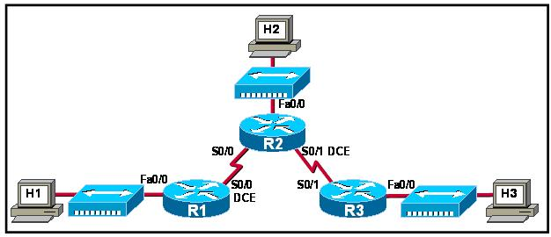
- All hosts
The topology is as follows Each router has a host connected to its Fa0/0. Router 1 (Named R1) is connected via S0/0 DCE to Router 2 (named R2) s0/0. R2 is connected via s0/1 DCE to router 3 (named R3) s0/1.

Your task is to assign addresses to the interfaces of all three routers, perform basic RIP on all three routers, and apply an access control list configuration on the appropriate interface in a three-router network, as pictured on the Topology tab.
Specifically, you must do the following:
- Determine and apply the appropriate IP addresses to the router interfaces. The addresses should be assigned from the network 172.23.0.0 using a /27 subnet mask. The appropriate addresses are identified in the table below. NOTE:Subnet zero IS NOT counted as the first subnet.

Pertinent Information | Router R1 | Router R2 | Router R3
Fa0/0 IP Address | last usable address of first subnet | last usable address of third subnet | last usable address of fifth subnet
S0/0 IP Address | first usable address of second subnet - | last usable address of second subnet - | Not Connected
S0/1 IP Address | Not Connected | first usable address of fourth subnet - | last usable address of fourth subnet -
- Enable RIP on all three routers to route all network traffic.
- Create a named access list that denies only ping and Telnet from the host H3 to the host H2.
- Apply the access list so that the router will perform most efficiently when filtering traffic. You should be able to test connectivity from all routers and hosts to all other routers and hosts before submitting your work.

