12.2.3 Optional Lab: Create a Partition in Windows 7

Introduction

Print and complete this lab.

In this lab, you will create a FAT32 formatted partition on a disk. You will convert the partition to NTFS. You will identify the differences between the FAT32 format and the NTFS format.

Recommended Equipment
- Computer running Windows 7
- Unpartitioned space of at least 1 GB on the hard disk drive

Note: You may need to substitute different drive letters for the letters shown in this lab.

Step 1
Log on to Windows as an Administrator.

Click Start.

Right-click Computer > Manage.

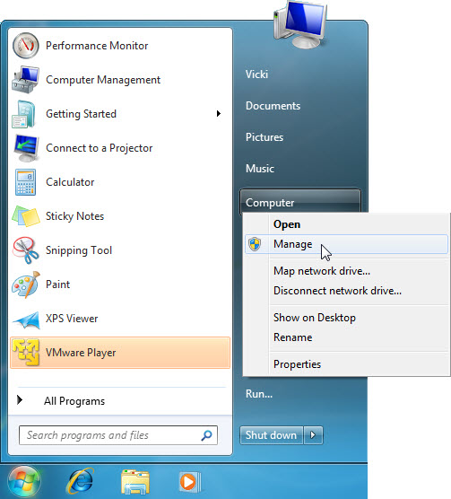

Step 2
The Computer Management window appears.

Click Disk Management on the left side of the screen.

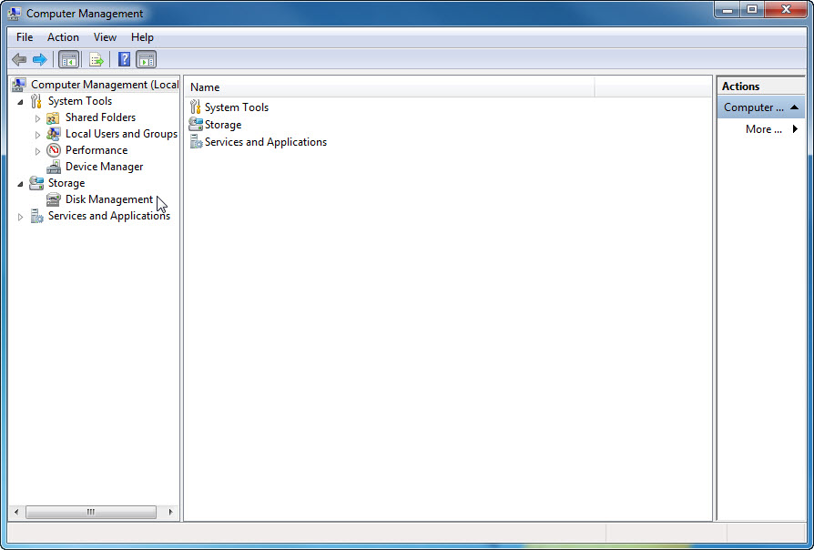

Right-click the green-outlined block of Free Space.

Click New Simple Volume….

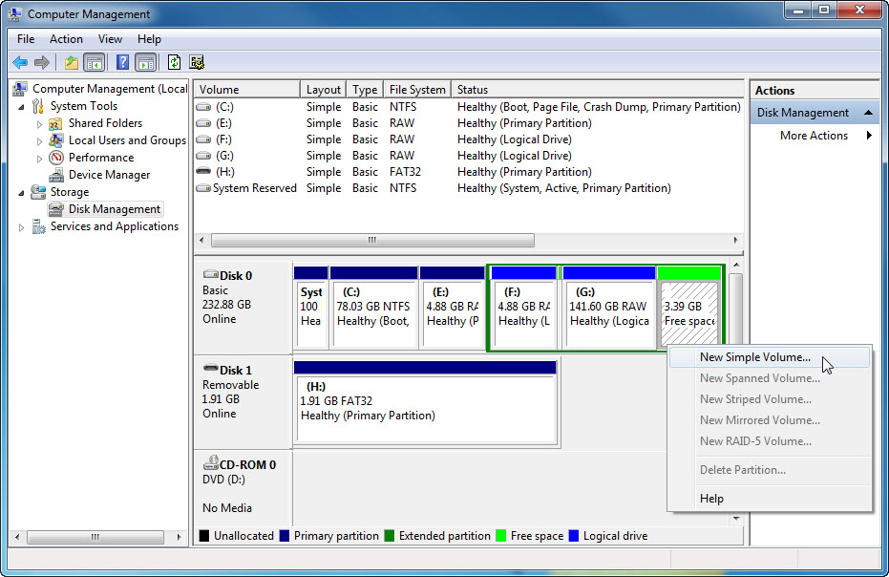

Step 3
The New Simple Volume Wizard window appears.

Click Next.

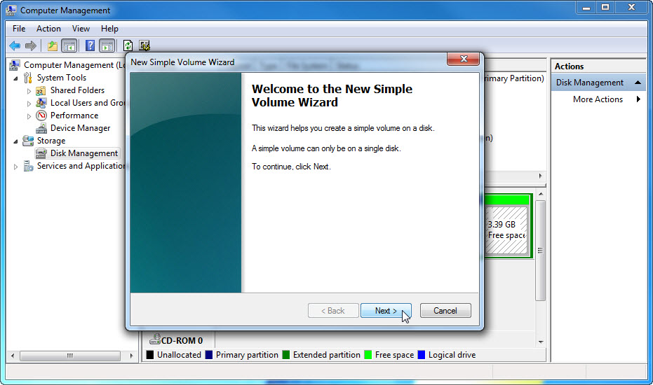

Type 500 in the Simple volume size in MB: field.

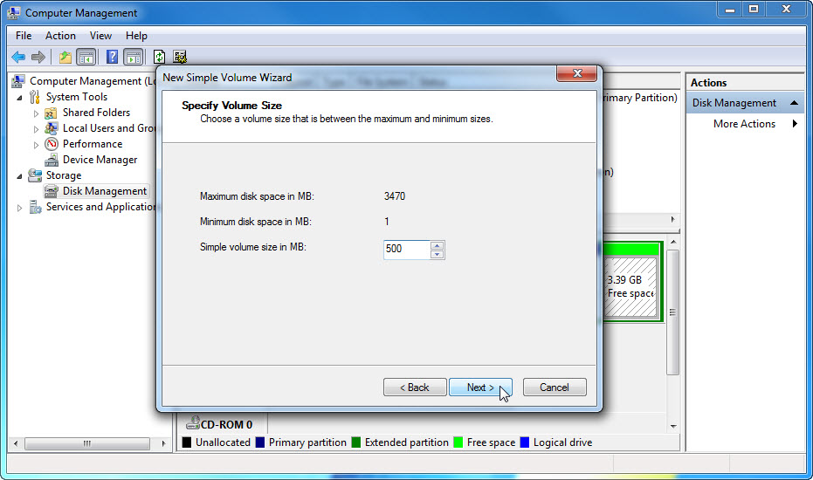

Click Next.

Click the Assign the following drive letter: radio button.

Select J from the drop-down menu.

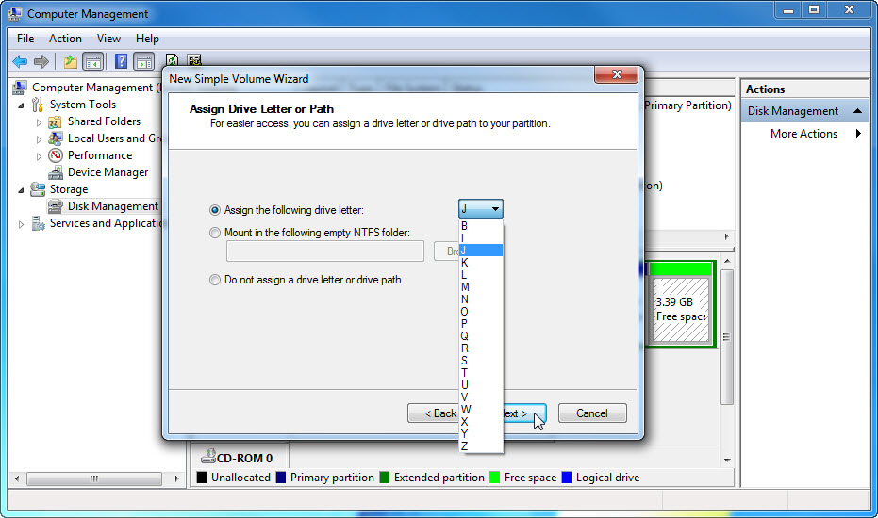

Click Next.

Click the Format this volume with the following settings: radio button.

Select FAT32 from the File system drop-down menu.

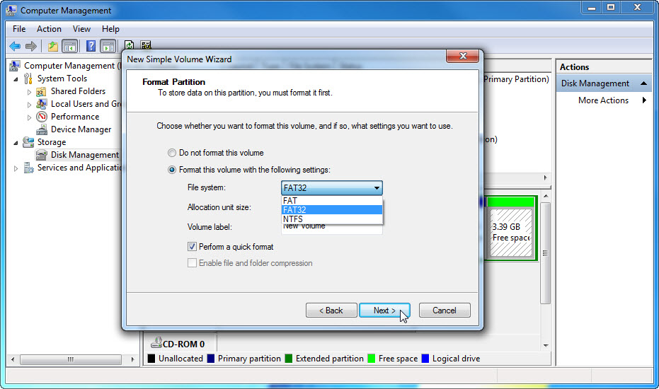

Click Next.

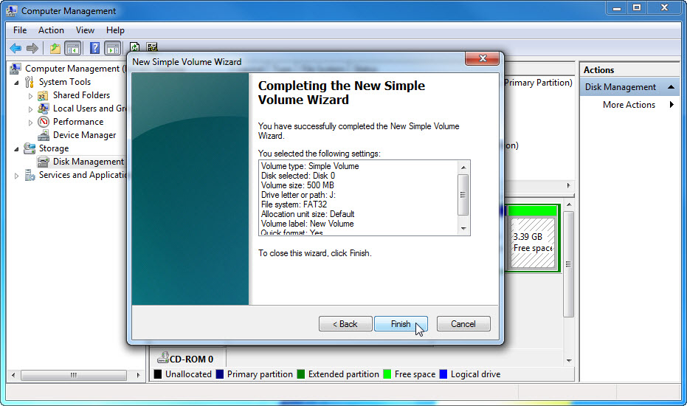

Click Finish.

Step 4
The Computer Management window re-appears while the new volume is formatted.

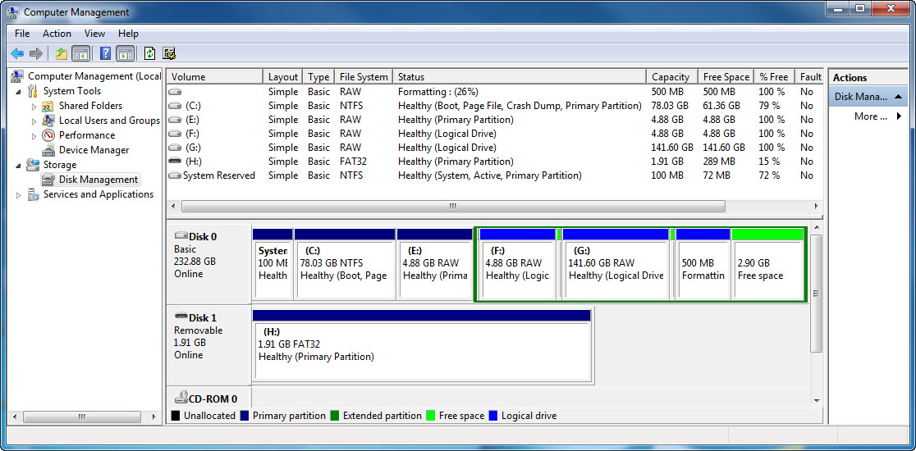

The Computer Management window shows the new Healthy (Logical Drive) volume.

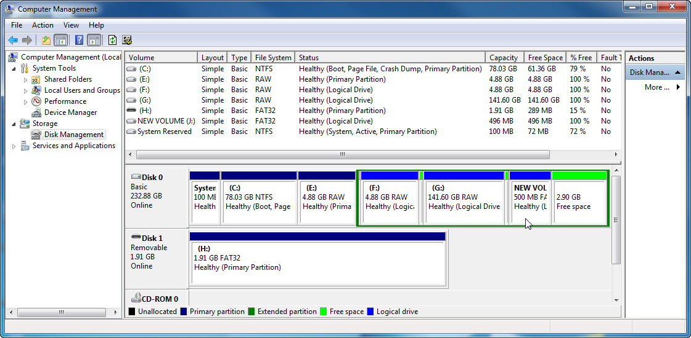

Step 5
Open Computer.

Click the NEW VOLUME (J:) drive.

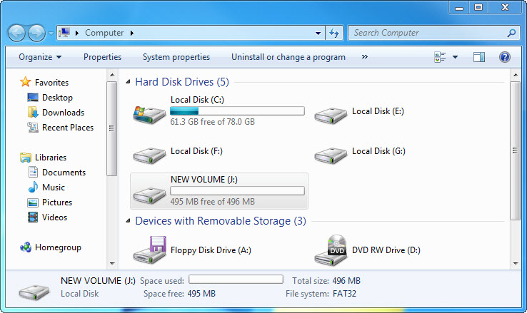

The Details area on the bottom of the Computer window displays information about the J: drive.

What is the File System?

How much Free Space is shown?

Right-click the NEW VOLUME (J:) drive.

Click Properties.

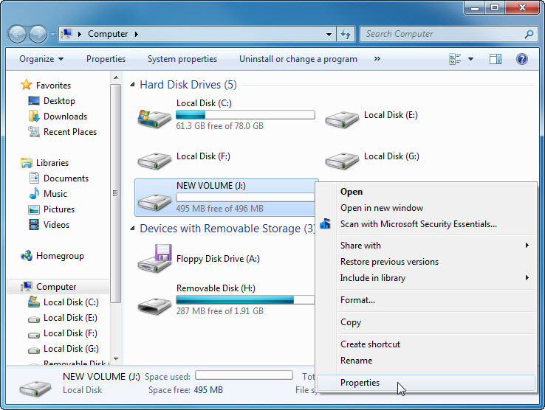

Step 6
The NEW VOLUME (J:) Properties window appears.

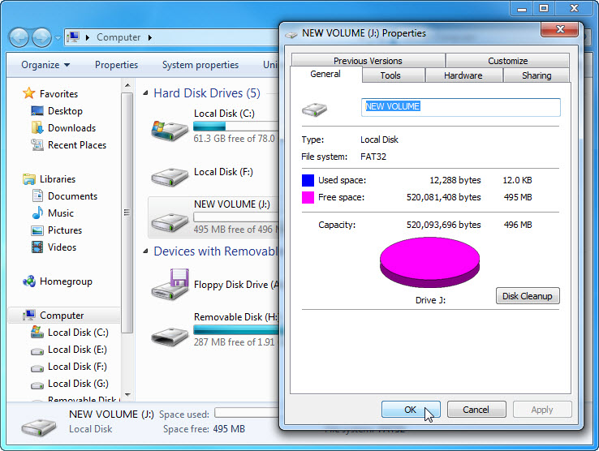

What is the File system of the J: drive?

List the tabs found in the NEW VOLUME (J:) Properties window.

Click OK.

Double-click the NEW VOLUME (J:) drive.

Step 7
Right-click anywhere in the white space of the window.

Click New > Text Document.

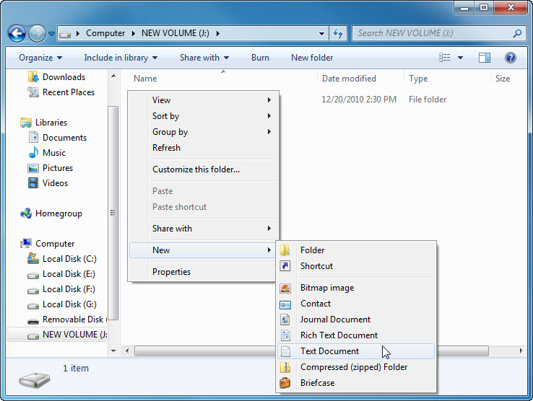

Type Test and press Enter.

Step 8
Right-click the Test document in the window and choose Properties.

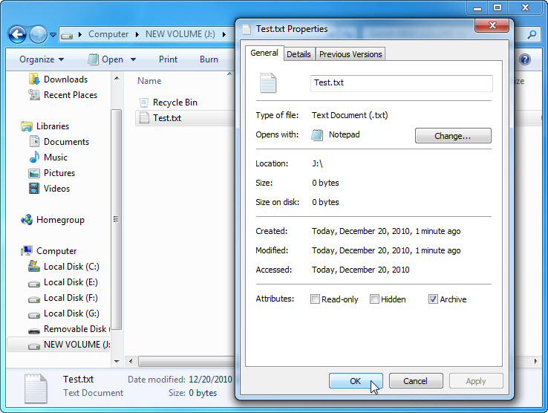

The Test Properties window appears.

List the tabs found in the Test Properties window?

Click OK.

Close any windows open for the J: drive.

Step 9
Click Start.

In the Search programs and files field, type cmd. When the cmd program appears, right-click cmd > Run as administrator.

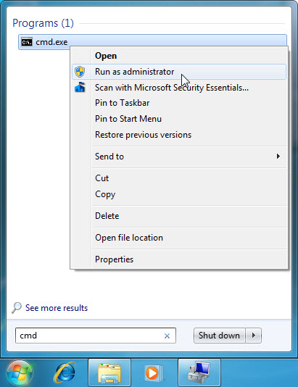

Click Yes if prompted by User Account Control.

Step 10
The Administrator: C:\Windows\System32\cmd.exe window appears.

Type convert J: /fs:NTFS > press the Enter key.

The convert command changes the file system of a volume without losing data.

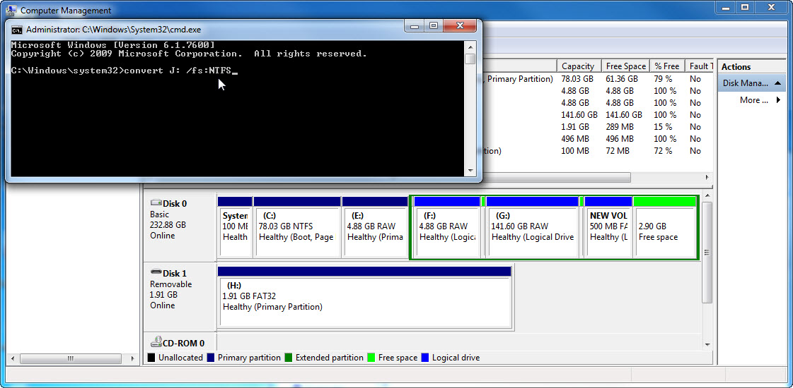

You will be prompted to enter the current volume label for drive J:. Type NEW VOLUME and the Enter key.

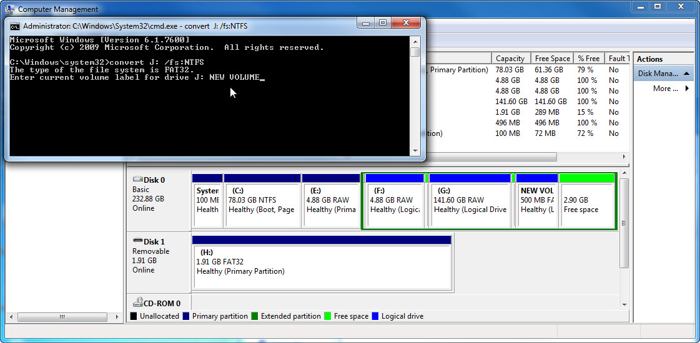

After the drive is converted, type exit in the Administrator: C:\Windows\System32\cmd.exe window, and then press Enter.

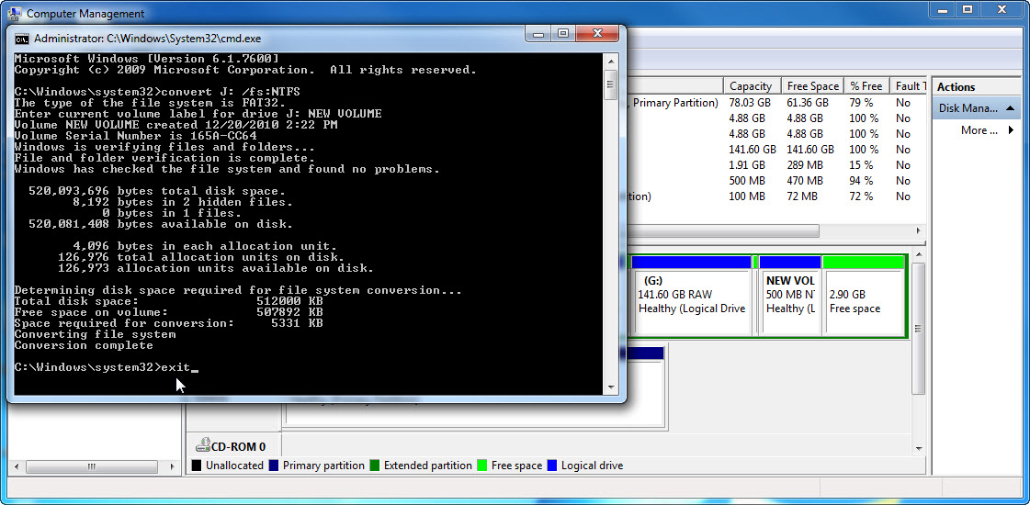

Step 11
The C:\WINDOWS\System32\cmd.exe window closes.

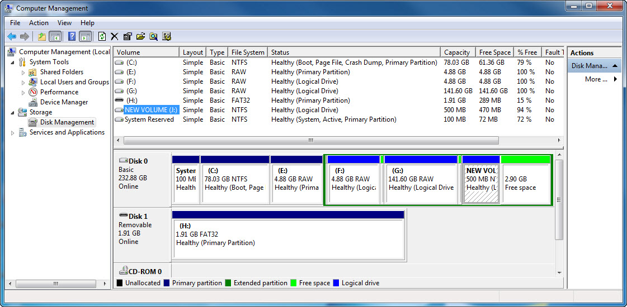

What is the File System of the J: drive?

Step 12
Open Computer.

Right-click NEW VOLUME (J:) > Properties.

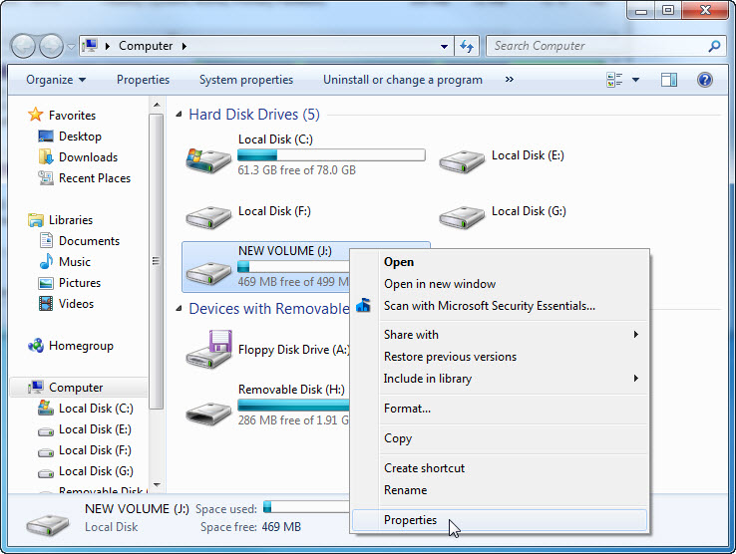

Step 13
The NEW VOLUME (J:) Properties window appears.

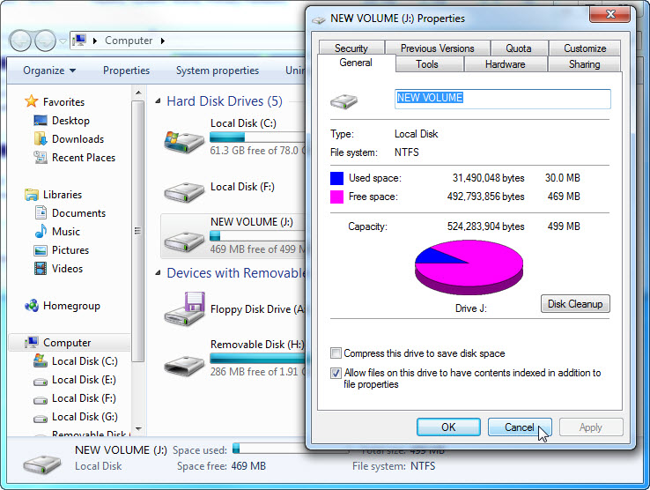

What are the tabs in the NEW VOLUME (J:) Properties window?

When the volume was FAT32, there were six tabs. What are the names of the new tabs that were added after the volume was converted to NTFS?

Click Cancel. Double-click the NEW VOLUME (J:) drive.

Step 14
Right-click the Test document > Properties.

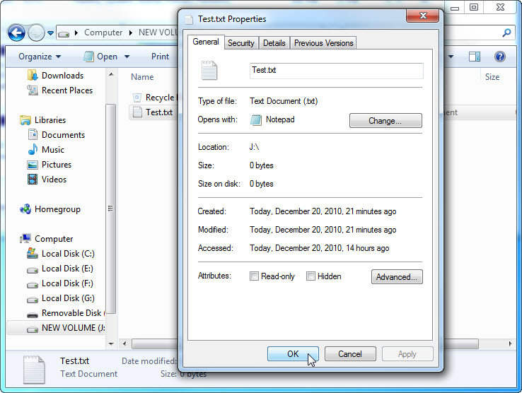

What are the tabs in the Test Properties window?

When the volume was FAT32, there were three tabs. What is the name of the new tab that was added after the volume was converted to NTFS?

Click OK.

