11.4.1 Optional Lab: Install a NIC in Windows 7

Introduction

Print and complete this lab.
In this lab, you will install a NIC, verify NIC operation, and manually configure an IP address, and set the NIC to use DHCP in Windows 7.

Recommended Equipment
- Computer running Windows 7
- PCI NIC or PCIe NIC
- Driver files for PCI NIC or PCIe NIC on a CD or USB flash drive
- Antistatic wrist strap
- Tool kit

Step 1: Open the Device Manager
- Log on to the computer as an Administrator.

- Click the Start button. Right-click Computer, and then choose Properties.

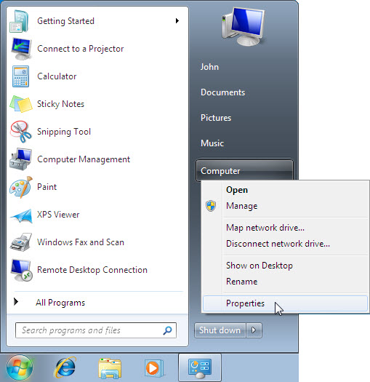
The “System” window appears.

- Choose the Device Manager link.

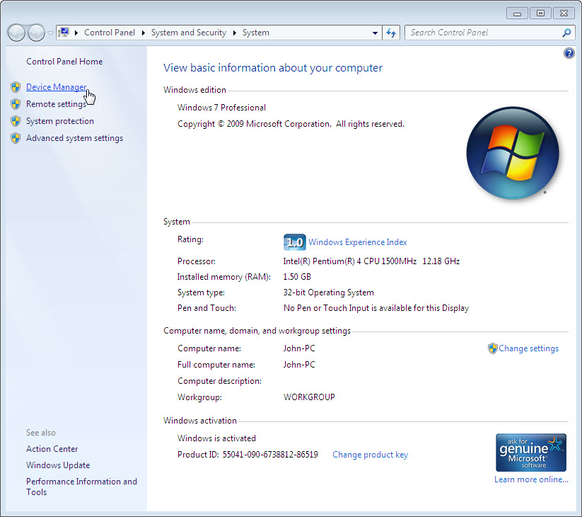

The Device Manager window appears.

Step 2: Disable any NICs
- Expand Network adapters.

- Right-click the NIC or NICs installed in your computer, and then choose Disable.

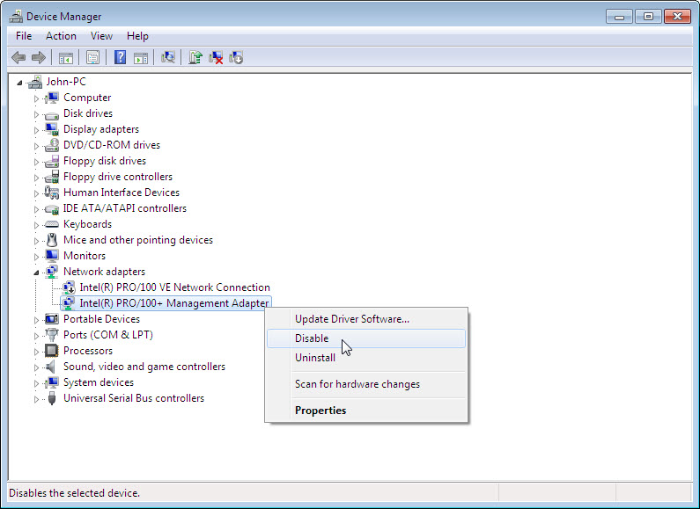
The “Disabling this device will cause it to stop functioning.” confirmation window appears.

- Click Yes.

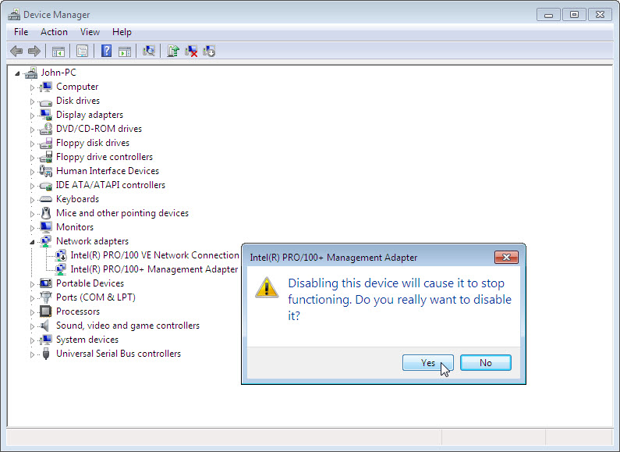

A black arrow () appears over the icon of the NIC installed in your computer.

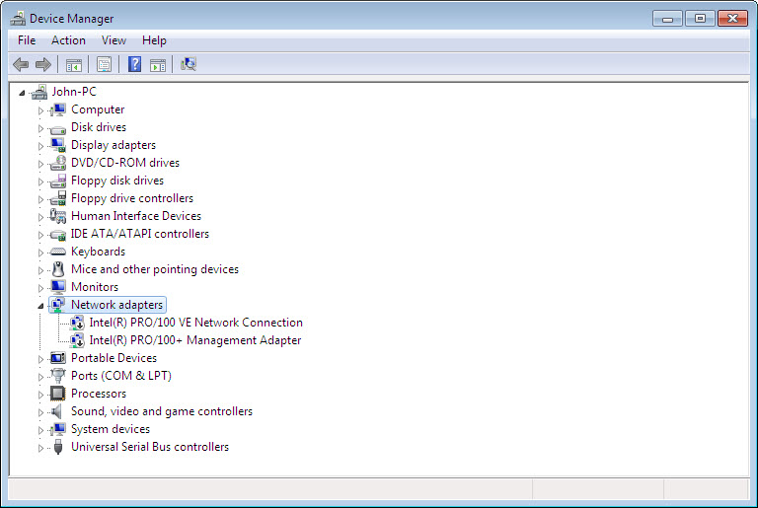

- Close the Device Manager window.
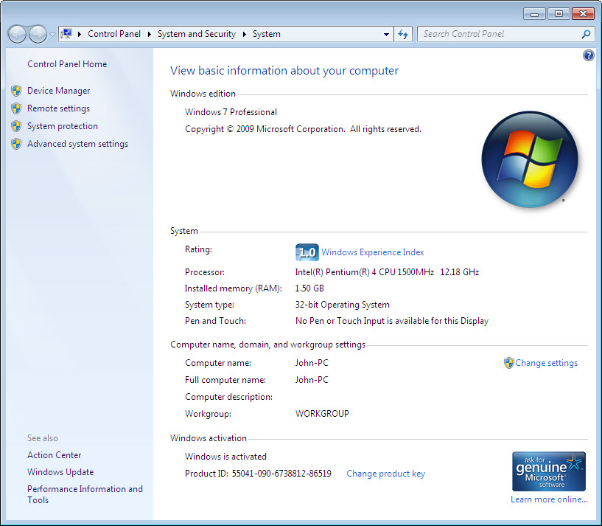

- Close the System window.

- Turn off your computer.

Who is the manufacturer of the new NIC?

What is the model number of the new NIC?

What slot type is used to connect the new NIC to the motherboard?

Step 3: Open the case
- If a switch is present on the power supply, set the switch to “0” or “OFF”.

- Unplug the computer from the AC outlet.

- Unplug the network cable from the computer.

- Remove the side panels from the case.

Step 4: Insert the NIC
- Choose an appropriate slot on the motherboard to install the new NIC. You may need to remove the metal cover near the slot on the back of the case.

- Make sure the NIC is properly lined up with the slot.

- Push down gently on the NIC.

- Secure the NIC mounting bracket to the case with a screw.

Step 5: Close case and restart the computer
- Replace the case panels.

- Plug the network cable into the new NIC.

- Plug the power cable into an AC outlet.

- If a switch is present on the power supply, set the switch to “1” or “ON”.

- Boot your computer, and then log on as an administrator.

- Windows will attempt to install a driver for the new NIC.

- Choose Start. Right-click Computer, and then choose Properties.

- Click the Device Manager link.

Step 6: Install a new driver
The “Device Manager” window appears.

- Expand Network adapters. If Windows was not successful at installing a driver for the NIC you will see a yellow exclamation mark next to the device icon.

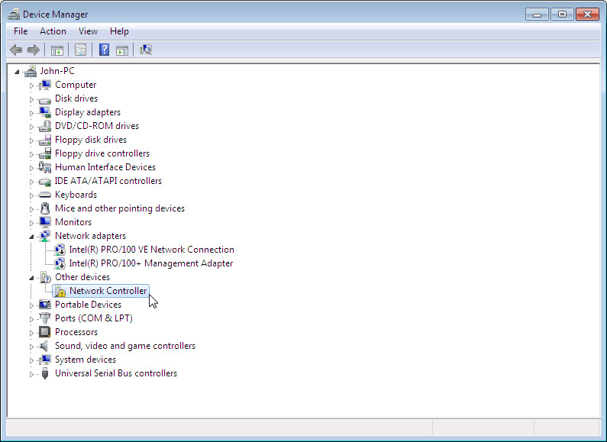

How many Network adapters are present (enabled and disabled) in the list?

- Right-click the new NIC icon or Ethernet controller, and then choose Properties.

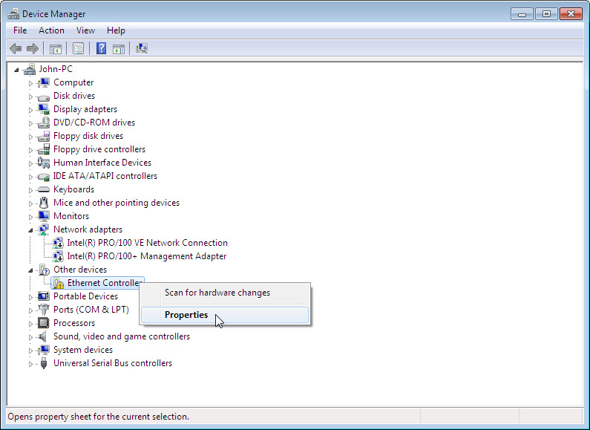

- Click the Update Driver button.

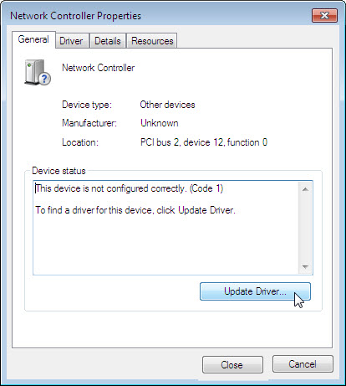

The “Update Driver Software – Network Controller” wizard appears.

- Click Browse my computer for driver software.

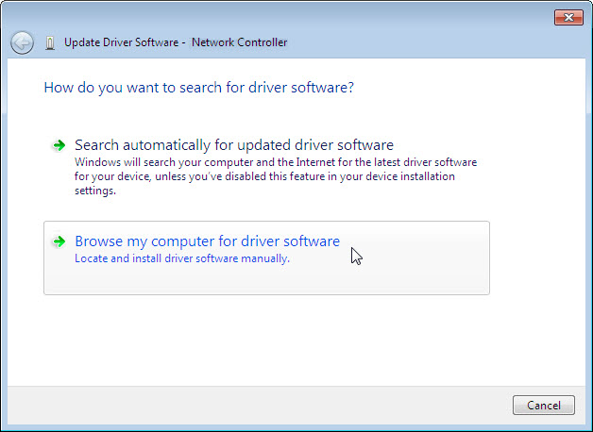

- Insert the CD or USB flash drive with the new NIC drivers, and then click Browse.

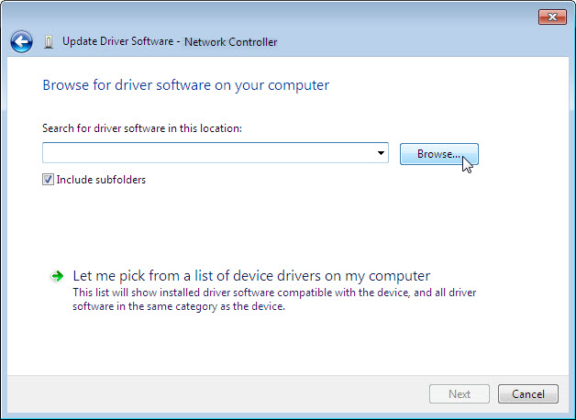

- Select the location that contains the driver then click OK.

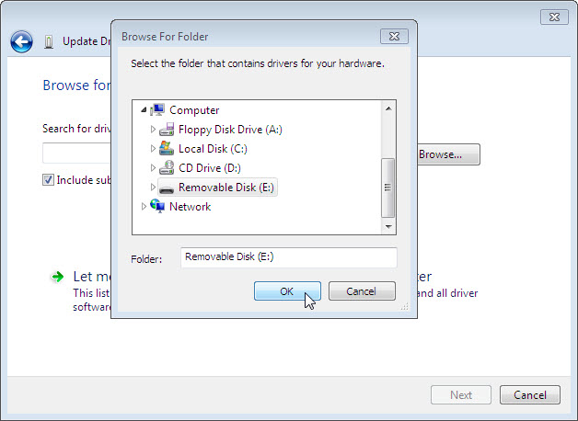

- Click Next to start the search.

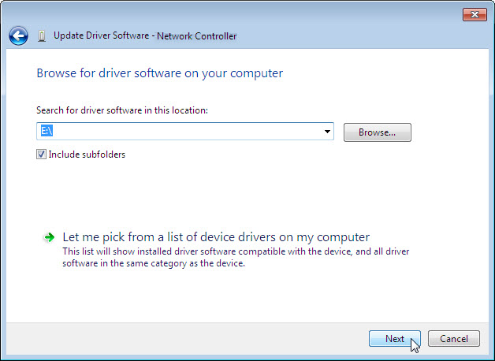

- The “Searching E:\ for software…” window appears.

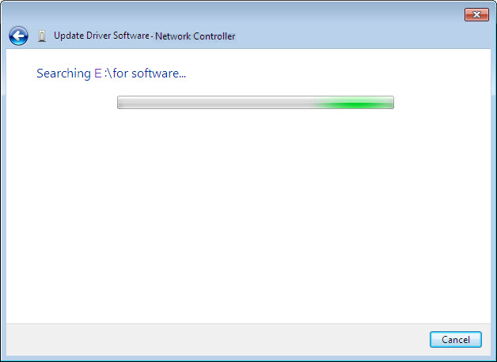

- Click Close after Windows installs the new driver.

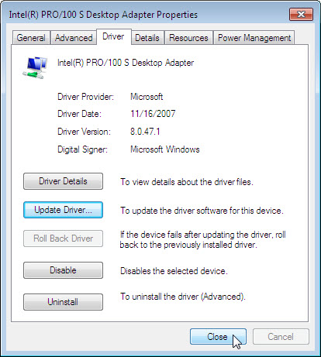

- Close the Device Manager.

Step 7: View the NIC settings
- Choose Start > Search programs and files.

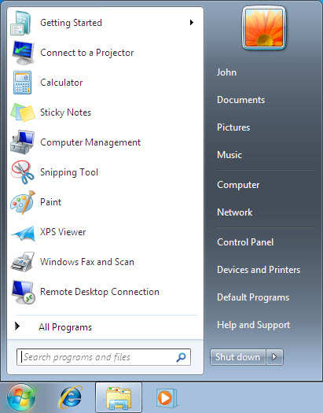

- Type cmd and press Enter.

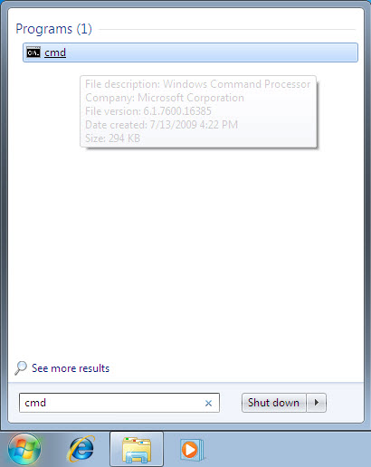

The “C:\WINDOWS\System32\cmd.exe” window appears.

- Type ipconfig and press Enter.

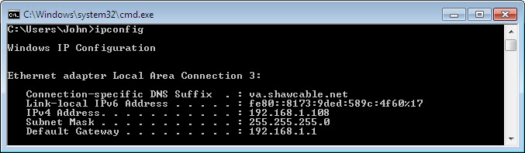
The settings of the new NIC are displayed.

What is the IP address?

What is the subnet mask?

What is the default gateway?

Step 8: Open the Network Connections window
- Choose Start > Network.

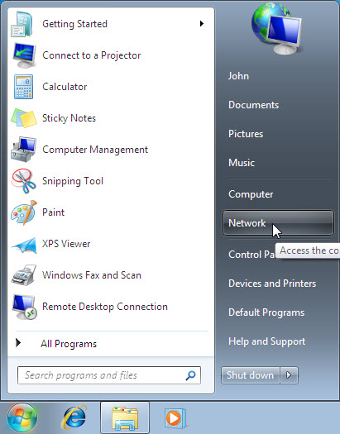
Click Network and Sharing Center.

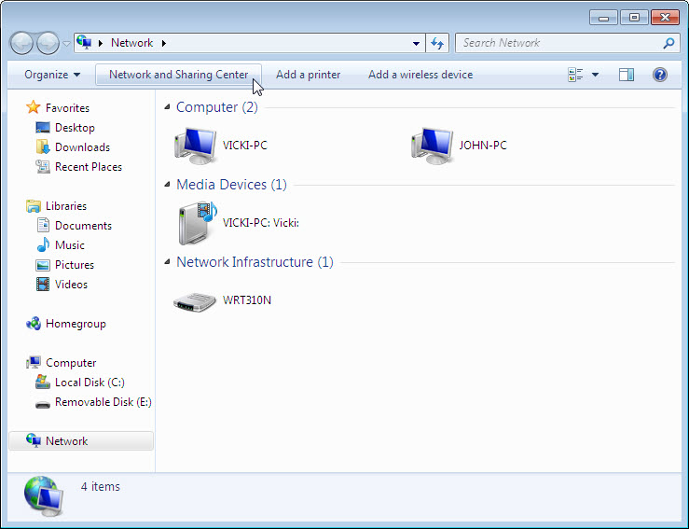

The “Network and Sharing Center” window appears.

- Click Change adapter settings.

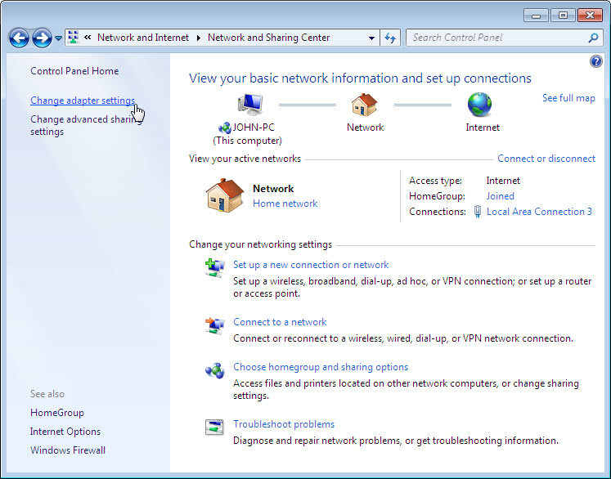
The “Network Connections” window appears.

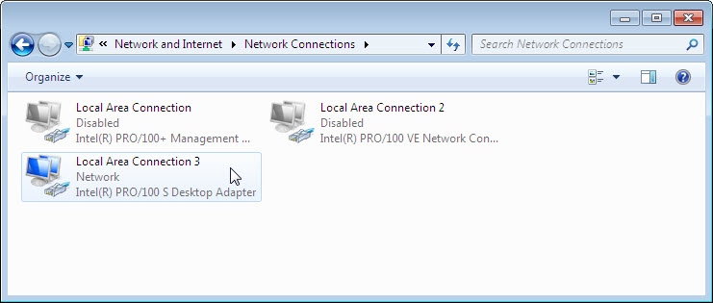

Step 9: Set a static IP address
- Right-click the connected “Local Area Connection 3” and choose Properties.

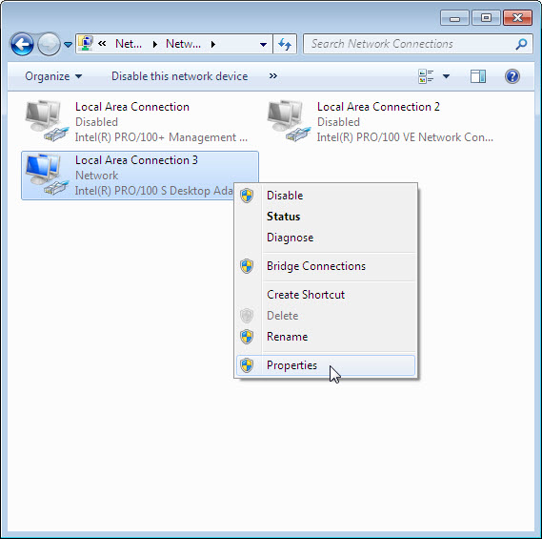
The “Local Area Connection 3 Properties” window appears.

- Choose Internet Protocol Version 4 (TCP/IPv4) and click Properties.

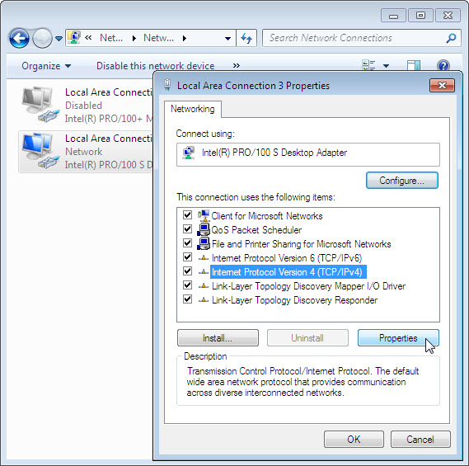

- Click the Use the Following IP address: radio button.

Note: Use the IP address, subnet mask, and default gateway you wrote down earlier in the lab to fill in the following three fields:

- Type the IP address assigned to your computer in the “IP address” field.

- Type the subnet mask assigned to your network in the “Subnet mask:” field.

- Type the default gateway assigned to your network in the “Default gateway:” field.
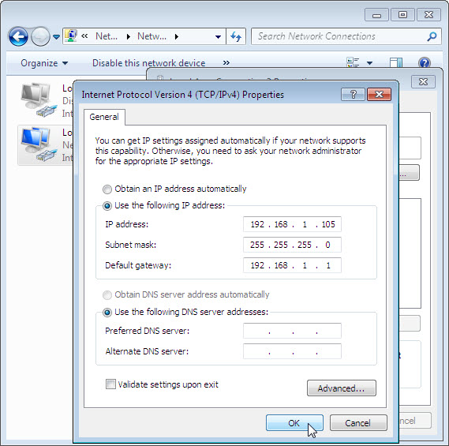

- Click OK.

The “Internet Protocol Version 4 (TCP/IP) Properties” window closes.

- Click Close.

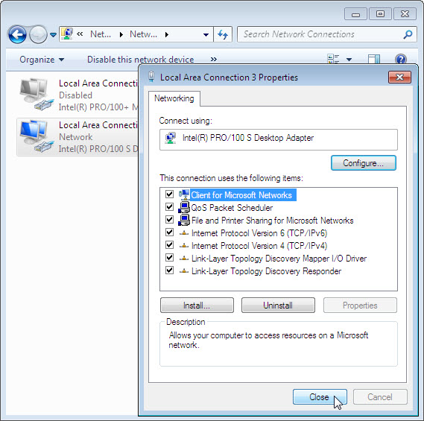
The “Local Area Connection 3 Properties” window closes.

Step 10: Ping your computer
The “C:\WINDOWS\System32\cmd.exe” window is revealed.

- Type ipconfig /all, and then press Enter.

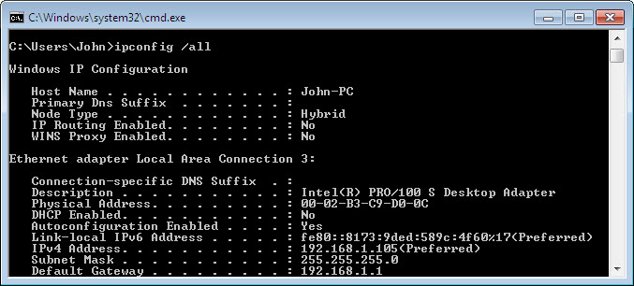

Does the NIC have DHCP enabled?

- Type ping and your IP address. For example, ping 192.168.1.105.

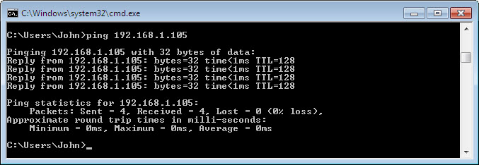

Write one of the replies of your ping command.

- Type exit, and then press Enter.

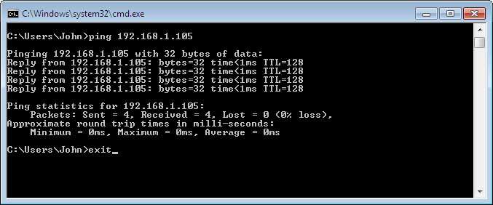

Step 11: Set the NIC to use DHCP
- Choose Start > Network.

- Click Network and Sharing Center.

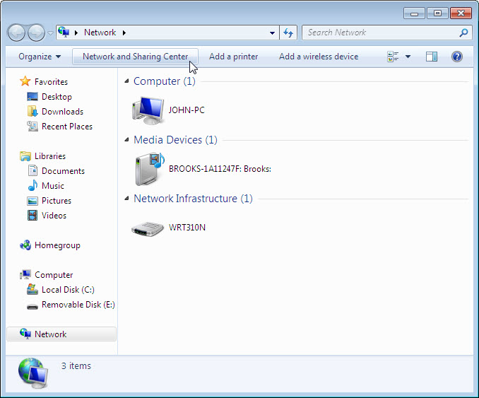

The “Network and Sharing Center” window appears.

- Click Change adapter settings link.

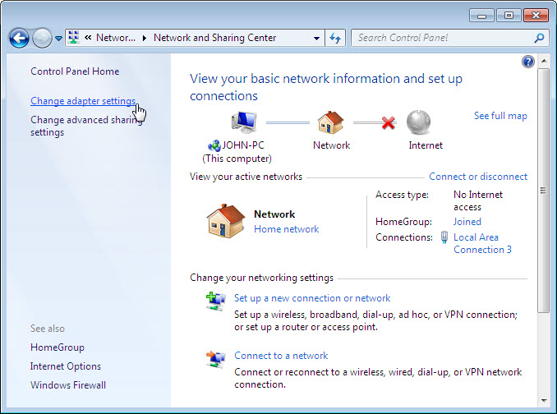
The “Network Connections” window appears.

- Right-click the connected “Local Area Connection 3” and choose Properties.

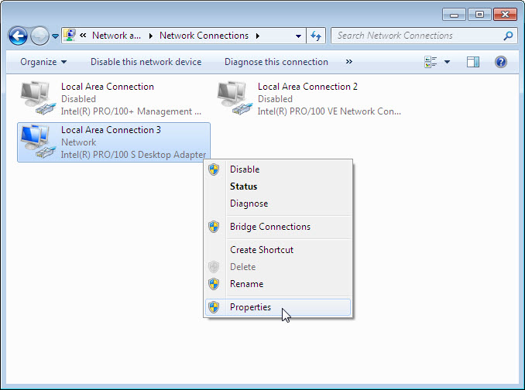

The “Local Area Connection 3 Properties” window appears.

- Choose Internet Protocol Version 4 (TCP/IPv4) and click Properties.

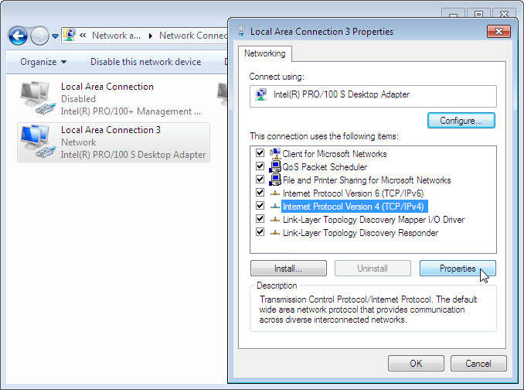

- Click the Obtain an IP address automatically radio button.

- Click OK.

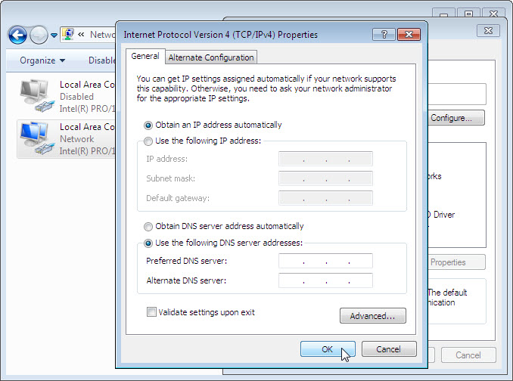

The “Internet Protocol Version 4 (TCP/IPv4) Properties” window closes.

- Click Close.

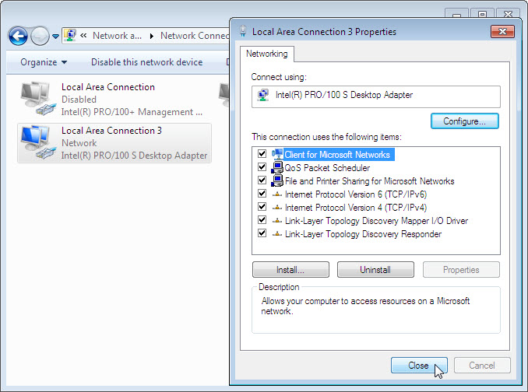

The “Local Area Connection 3 Properties” window closes.

